Kohn Wants To Keep Funny Money™ Window Open Forever

May 31, 2008
Elaine Meinel Supkis
Today we must discuss the astonishing speech by Federal Reserve Vice Chair Kohn. Kohn rose to his high throne after he pushed hard for the Greenspan interest rate cuts to 1%. He sat on his ass during the housing bubble and is now working hard on rescuing the bankers and investment houses that dumped trillions in worthless loans on top of the planet's banking systems. His fix is to take the new emergency regime of the Fed accepting lousy loans as collateral for making Funny Money™ and to do this FOREVER. And he wants an international Funny Money™ clearing house that accepts ONLY VERY SAFE collateral. But this fool can't say what this mysterious VERY SAFE collateral will be. This is because he would have to say, 'GOLD' and the gold markets will go wild with joy as they ought. The Fed has to find some way of getting back the gold standard but we can't, we are bankrupt as a nation. Only China and Russia can do this. We know how this story will end.
Fed might accept foreign collateral: Kohn
The Federal Reserve is actively considering creation of a lending facility that would accept "very safe" foreign collateral from "sound" global banks in case of a widespread liquidity crisis, Fed Vice Chairman Donald Kohn said Thursday.
A new global discount window is "under active study," Kohn said. "It is possible that over time, major central banks could perhaps agree to accept a common pool of very safe collateral, facilitating the liquidity management of [bailing out by]global banks," he said, stipulating that such loans only be made to sound institutions.
Quiz time: what is 'very safe collateral'? That has to be something that is like a certain shiny metal that didn't degrade over time. Yeah! I know! GOLD! HAHAHA. It is funny, watching the news lately. Online, we have been debating the utility and value of gold vis a vis paper currencies. I have had mixed feelings about gold much of my life. But as I debated with others online, certain concepts became clearer and clearer.
- One chief idea is that gold functions best when it is a near-monopoly of the government banking system and that government is a democracy so there is input from the populace.
- The second idea is, gold does NOT work if everyone tries to use it, it works best when the top empires use it as a basis for finances. Then, all other financial systems can latch onto the imperial gold standard and run vis a vis this.
- The third thought was, all empires give in to natural greed and cease using gold as a restraint on spending and instead, basically ditch it and simply make money out of thin air. This is because all the other nations still think the money of the empire is 'good as gold' and track the paper currency faithfully.
- But along comes my fourth thought: this period of naivety lasts only about 20 years. Then chaos breaks out as the other nations realize the empire that is 'good as gold' is actually a 'dead beat' empire that can't pay its bills and has no gold, it is all now debts! Then the global banking system collapses until a new empire takes up the golden banner and moves to the forefront. Then all other nations reset their own paper currencies against the new imperial eagles and life goes on.
First the British Empire dropped the gold standard at the beginning of the Great Depression after spending 20 years defending it. The US nearly fell along with Great Britain. In 1933 the President via fiat seized the gold coins held by banks and savers. He then issued only paper against these coins and gold bars and took the heist to Fort Knox. After that, the dollar became the world's gold standard until 1972 when President Nixon unilaterally with the blessings of the Federal Reserve chiefs, severed this relationship totally. So the ENTIRE PLANET EARTH has not had a gold standard for a long, long time. But the fiction of an 'imperial gold standard' continues to this day via conspiratorial fiat. The top bankers of the world are simply PRETENDING the US Treasuries have the same value as gold. But they do not. They are IOUs based on future taxes. And government overspending since 1972 had meant the obligations in the future are rising faster than anticipated incomes. This means we are going bankrupt.
So, the central banks want 'VERY safe collateral' but NOT gold? Note how these weasels won't define what these mythological 'VERY safe collateral' things are! Like all things from the Cave of Death, this has to be cloaked in secrecy and darkness. We know that Kohn knows perfectly well what he really should say. Jewish bankers have been playing the gold/paper/scissors game for centuries! Recently, he and his buddies tried to convince us that gold was worthless and stupid and we should never use it as a basis for international trade banking. The G7 central bankers even sold of [off] thousands of tons of gold in the open markets to make their point only to see the price of gold shoot upwards!
So here they are, talking about their desire for a 'VERY safe collateral'? HAHAHA. Next: the 'sound' banks. THERE ARE NONE. They are all obviously bankrupt! Hiding this fact is very important. The trick here of our darling wizards is to point to a toad and say, 'This is good as gold' and then we worship it as the new god. Right now, they are fearful that this won't work so they are keeping this toad hidden from view for the time being. They will slip it into the gold vault in due time. And then tell us this is the most secure form of wealth. And a good basis for creating lending.
This story, by the way, is very important. So I am going to write one of my long, long articles examining the inner workings of this latest attempt at jiggering international banking so it produces wealth while not partaking of capitalist profits from value-added labor and trade. For this lies at the very heart of the present banking collapse.
Kohn Signals Wall Street May Get Permanent Access to Fed Loans
The remarks go beyond Fed Chairman Ben S. Bernanke, who has indicated the central bank would shut lending to investment banks when the credit crisis passes. Lawmakers and regulators are debating how to approach the supervision of investment banks in the aftermath of the Fed's rescue of Bear Stearns Cos. in March.
``If you are a bondholder in one of these Wall Street firms, you know you have a big `Sugar Daddy' now called the Federal Reserve that's going to back you up,'' said Jeff Pantages, chief investment officer of Alaska Permanent Capital Management in Anchorage, which oversees $1.8 billion in assets.
As usual, Bloomberg news carries contrary opinions. This is why I quote that service more than all others combined. Yes, the stock brokers, the bondholders all love the Federal Reserve. As previous articles here show clearly, the Fed operates only to please them. They get rescued the minute their billions of bonuses are threatened. Most of the time, the Fed enables them as they spend recklessly. The Fed will make a stab at stopping inflation or curbing wild lending only to give it up. Volcker was the only one to take it all the way to the end and succeeded in stopping raging inflation. But the stock brokers hated him. Indeed, bankers in general HATE HIGH INTEREST RATES except for DEBTORS. In other words, the ideal world for them is for HIGH consumer interest rates and LOW bond rates! Which is what? What the Fed is creating this very day! Since 2000, when the Fed dropped the rate for BONDS to 1%, mortgages were still well above 4.5%. When the Fed raised bond rates to 5%, mortgages were only slightly higher at 6.5%. But the SPREAD was very small compared to the great spread during the 1% regime.
So Sugar Daddy is protecting not the savings of people putting money in banks. Sugar Daddy is protecting the holders of all other bonds. Namely, the bonds used by bankers as 'assets' which can be used to make loans. Which, thanks to the low interest rates charged by the Fed, are again a huge spread vis a vis lending! The problems we see today are certainly due to debtors unable to pay the interest on these wide-spread loans. And on top of this, the consumer loans are going bad too! And these have humungous spreads! 2,000-3,000 basis points! These things are, in good times, 'good as gold.' This is because it is paid by workers putting in hours producing something.
But when production falls, the ability to pay vanishes and the principal of these consumer loans vanishes along with FUTURE interest payments. The principal lost is bad enough. But the future earnings is far greater in value in these loans. So this has great economic force to the downside.
Libor Fix May Prove Elusive as Banks Offer Solutions
The loss of confidence in the benchmark rate for $350 trillion in derivatives and corporate bonds and 6 million U.S. mortgages spurred the world's biggest banks to recommend fixes, though they reached no consensus. The BBA plans to announce after 5 p.m. today the first changes to Libor in 10 years after the Basel-based Bank for International Settlements suggested in March that some lenders were misstating borrowing costs to avoid speculation that they were in financial straits.
``The BBA clearly needs to fix Libor as it's not functioning as it should,'' said Jan Misch, a money-market trader in Stuttgart at Landesbank Baden-Wuerttemberg, Germany's biggest state-owned bank. ``How exactly they go about doing that I don't know.''
The loss of confidence in the Libor rate setting system is really due to the collapse of the banking system after the floating currency regime caused too much Funny Money™ creation. Global monetary output has shot upwards rapidly. At first, it was all soaked up by developing nations. But now it has nowhere to go and is now causing global inflation in things people use daily. Housing, food and fuel all are seeing catastrophic bubbles. Instead of understanding that this is an expression of excess monetary creation due to the US ending the gold standard, the bankers like to pin blame on anyone but themselves and their own systems. The Libor depended on a gold foundation. Since that is gone, it is sinking because currencies don't 'float'. They either sink or turn into balloons.
Now we must look at what Kohn actually said. It is worse than the news stories.
Vice Chairman Donald L. Kohn Market participants, scholars, and central bankers and other policymakers have long recognized that liquid money markets are critical to financial stability.
[Elaine: HAHAHA. I wish he would call this stupid 'liquidity' what it really is: RED INK]
Many banks and other financial market participants obtain a significant portion of their funding in the money markets and rely on rolling over such short-term debt. Developments in global financial markets since last summer have underscored that if market participants become concerned about their access to money market funding, they can pull back from providing credit to other financial market participants and to businesses and households. Furthermore, certain liquidity tools traditionally used by central banks may not be fully effective in restoring liquidity to the money markets and containing the threats such money market disturbances pose to financial stability.
[Elaine: No kidding! Only it isn't the lack of 'liquidity' that is threatening the system, it is TOO MUCH liqudity! We are drowning in red ink.]
We all need to reflect carefully on these developments and draw appropriate lessons regarding the management of liquidity risk and the design of central bank liquidity facilities.
The financial turmoil that we have been experiencing since last summer clearly did not originate in the money markets. As everyone knows [oyeah], the trigger was losses associated with soaring delinquencies on U.S. subprime mortgages that were originated from 2005 through early 2007, a period during which underwriting standards for such mortgages weakened dramatically.
[This is total BS. Kohn is either lying or stupid or both. The financial turmoil originated IN THE FEDERAL RESERVE. Of course, this idiot won't tell the truth, would he? And his 'everyone knows' the mess was started by a bunch of silly home buyers who took on loans they couldn't afford! All 30 million of these nonbankers are the cause! Talk about utter tripe!]
*snip*
I believe that the depth, scope, and persistence of the financial turmoil we have been experiencing is in significant part attributable to broader concerns about the liquidity of money markets. A loss of liquidity in a money market [MZM] generally has more serious effects than a loss of liquidity in markets for longer-term instruments because such large amounts of money market instruments become due each day. If investors pull back from a money market, the issuers come under substantial liquidity pressures very suddenly. In the case of ABCP, with the exception of paper issued by structured investment vehicles (SIVs) and so-called extendible paper, issuers were able to meet those liquidity demands by drawing on committed lines of credit from banks. But that simply transferred the liquidity pressure to the banking system. Banks generally were able to cope with that pressure, but the need to fund the draws on their backup lines ate substantially into their liquidity and capital buffers. Thus, credit problems in mortgage markets helped reduce the availability of credit across a wide variety of instruments and borrowers.
[Elaine: Note that even this guy admits that the problem isn't long term lending, it is SHORT TERM, overnight or weekly lending. And again, naming things correctly is important. The 'investors' are really SAVERS. If a bank cheats them, they won't put money in a bank and it goes bankrupt. Duh. The only cure is to raise interest rates. The problem this year wasn't a lack of savers willing to lend money to banks. It was the refusal of the bankers to pay a reasonable interest rate! So the told the investors, the real rate was well below the rate of inflation. So the investors took their money into the commodity markets to get a return faster than the rate of inflation. This, in turn, caused inflation to shoot upwards. Horns of dilemma! A sign that the system is totally out of whack.]
The pressure on their liquidity and on their balance sheets, combined with heightened credit concerns, made banks reluctant to provide others with term funding--that is, money market loans with terms longer than overnight. Term premiums embodied in interbank money markets increased markedly; at times the spreads between term dollar Libor and comparable-maturity overnight index swap rates exceeded 100 basis points, and term premiums of comparable magnitude also emerged in interbank markets for sterling and euros. Securities firms and hedge funds also found term funding considerably more costly and difficult to obtain after the strains emerged in the ABCP markets. Convinced that the illiquidity of money markets and persistently enlarged term premiums were a significant impediment to restoring the effectiveness of financial market functioning, the Federal Reserve in late 2007 and early 2008 took steps to make borrowing at the discount window more attractive to banks and provided greater liquidity to primary dealers in U.S. government securities by extending the maturity of its open market operations.
[Elaine: Boo hoo hoo. See what I mean? The spread grew because the central bankers lied about inflation and maliciously lowered rates when rates should have gone UP. So the spreads accurately reflected this harsh fact.]
However, this private-sector intermediation process in money markets became severely impaired in the recent turmoil. As I already mentioned, uncertainty about the value of assets, about the creditworthiness of counterparties, and about future calls on the liquidity and capital of important market participants caused liquidity to dry up in many segments of the money markets. A flight to liquidity and safety is not unusual when uncertainty rises and markets are disturbed, but the breadth and persistence of this turmoil and its spread into money markets made it a substantial threat to financial and economic stability.
To ameliorate the threat to financial and economic stability, the Federal Reserve and a number of other central banks in effect found they needed to provide a substitute for the arbitrage and trading no longer being undertaken in sufficient size by the private sector. These central banks changed the composition of their balance sheets, selling or lending the assets that were in especially strong demand and lending against the illiquid assets the private sector was having difficulty financing. The purpose of those moves has been to forestall fire sales of assets that could no longer be financed, to facilitate orderly deleveraging and reintermediation in the financial sector, and to encourage the reopening of private markets for securitization products so that price discovery could proceed and credit flows resume.
[Elaine: The 'fire sale' was turned into generalized inflation. So instead of the banks and investment houses being burned, they got free money from the Fed which they, in turn, fed directly into the commodities markets creating a huge increase in global inflation. They should be all arrested for fraud, the central bankers and their buddies who got this free money.]
*snip*
I start from the premise that central banks should not allocate credit or be market makers on a permanent basis. That should be left to the market--or if externalities or other market failures are important, to other governmental programs. The Federal Reserve should return to adjusting reserves mainly through purchases and sales of the safest and most liquid assets as soon as that would be consistent with stable, well-functioning markets. In fact, several of the Federal Reserve's new programs are designed to be self-liquidating as markets improve. Minimum bid rates and collateral requirements have been set to be effective when markets are disrupted but to make participation uneconomic when markets are functioning well. Under current law, our facilities for investment banks that don't involve securities eligible for open market operations (OMO-eligible paper) will necessarily be wound down when circumstances are no longer "unusual and exigent"; I'll come back to questions about these facilities in a minute.
[Elaine: Kohn wants 'business as usual' which is where the US government overspends, creates Treasuries which the Fed buys and the US government pays the Fed interest on and then this is passed on through the banking system and is used as the basis for creating more new debts. Only it is debt! It is NOT wealth or something outside of debt creation cycles. It is NOT capital. The banks are so contemptuous of savings and capital, they insult savers and capitalists with ridiculous interest rates for the privilege of using these savings to make profits off of loans! So the bankers conspire with the central bank to turn dross into gold. Again: the loss of gold as the basis means using debt as gold. And this leads to a negative system that is pure black hole. Very unstable and dangerous.]
*snip*
However, the Federal Reserve's auction facilities have been an important innovation that we should not lose. They have been successful at reducing the stigma that can impede borrowing at the discount window in a crisis environment and might be very useful in dealing with future episodes of illiquidity in money markets.
[Elaine: This mysterious 'stigma' is not a bloody palm or forehead. This is the fear that when the news that a bankrupt bank has to go to the Fed and hand over worthless paper they can't sell, this means the bank is BANKRUPT. And then there will be a 'run on the bank' as they say. Already, there is a run on the banks! No one is saving money! The ridiculous interest rates are luring in no money! So instead of raising rates, the Fed has conspired to keep them low via tricks.]
The new auction facilities required planning and changes in existing systems, and we should consider retaining the new facilities for the purposes of bank discount window borrowing and securities lending against OMO-eligible paper, either on a standby basis or operating at a very low level when markets are functioning well in order to keep the new facilities in good working order. The latter might require that we allow the auction to set the price without a constraining minimum, but a small auction should not distort the allocation decisions of private participants.
[Elaine: In other words, the Fed is going to keep on doing this forever. It means that even the fiction that Treasuries are secure is not enough. Now they will claim that dead beat loans that can't be sold to savers are really worth something and then use THIS to lend banks more money. This also means bankers will NEVER have to entice savers for capital. They can just skip that step and go right to the magic money making machine and grind out loans merrily.]
*snip*
Our experience in recent months has underlined the global interdependencies of financial markets. Globally active banks manage their positions on an integrated basis around the world, and pressures originating in one market are quickly transmitted elsewhere. Central banks should consider how to adapt their facilities to help these institutions mobilize their global liquidity in stressed market conditions and apply it to where it is most needed. That approach will require the consideration of arrangements with sound institutions in which central banks would accept foreign collateral denominated in foreign currencies. Those arrangements are under active study and a number of issues need to be resolved. It is possible that over time, major central banks could perhaps agree to accept a common pool of very safe collateral, facilitating the liquidity management of global banks. The stipulation that the institutions be sound is important: Decisions about lending to troubled banks should be made by home country authorities with knowledge and responsibility.
[Elaine: Here it is! The idea we need a new system that is sound and good. Only he won't say what on earth that is. Nor dare he say what it is. He knows it is all pure debt from all the major industrial nations and he knows this amount has ballooned ever since 1972 when Nixon killed the dollar/gold relationship.]
Another instrument of liquidity provision that central banks are examining is currency swaps to facilitate granting liquidity in other currencies. The central banks found currency swaps useful because the impediments to intermediation in money markets naturally extended to transactions across currencies as well as across maturities and counterparties. Supplying credit in dollars to banks in the euro area and Switzerland helped relieve pressure on those banks and in our markets. In recent months, the Fed was able to make currency swap arrangements on short notice but our reaction time could be even shorter if we keep such arrangements in place or on standby. Thinking carefully about which circumstances in the future would warrant the activation of such arrangements will be a useful form of contingency planning.
[Elaine: YIKES. He is saying the present 'emergency' system will be FOREVER! Eternally open. This of course, increases the ability to ignore risk. And this means more wild lending.]
For the United States, of course, perhaps the most difficult and important question involves access to central bank credit facilities by U.S. broker-dealers, including the primary dealers. Over the past several decades, the growing importance of broker-dealers and the increasing interconnections of these institutions with other parts of the financial marketplace have accompanied the shift to intermediation through securities markets rather than through commercial banks.
[Elaine: Here he is talking about the pirates and hell hounds of the offshore tax haven hedge funders and their ilk. Note that he won't tell people who and what they are. He does note that they have usurped a lot of power. And are a danger. He wants to coddle them so they can continue. He thinks this will prevent the system from collapsing. Remember: he thinks the system is collapsing due to deadbeat home owners!]
Financial markets in most other countries are dominated by universal banks; in those circumstances, securities activities are carried out in organizations that have access to the discount window and other aspects of the safety net we associate with commercial banks. As I have emphasized this evening, one of the things we learned over recent months is that broker-dealers, like banks, are subject to destructive runs when markets aren't functioning well, despite the fact that their borrowing in money markets is mostly secured and their assets mostly marketable.
[Elaine: Good grief! If their damn assets are mostly marketable, then they don't need Santa Bernanke to give them money in exchange for these things! And it is obvious that their loans exceed their collateral worth. Which is why they are all bankrupt.] And, in the case of Bear Stearns, we saw that a run on a major broker-dealer when markets were already disrupted by a flight to safety and liquidity could, through a chain of actions and reactions, threaten financial stability.
*snip*
We gave the primary dealers access to central bank credit under the unusual and exigent circumstances prevailing in mid-March. Their counterparties and creditors will presume that such access would again be granted if the health of the financial system is again threatened by loss of liquidity at the primary dealers. The public authorities need to consider several difficult issues with respect to access to the discount window. One is the circumstances under which broker-dealers should be permitted to borrow in the future. One possibility would be to confine such borrowing to circumstances in which the Federal Reserve judges that the stability of the financial system is at risk--as we did in March. Another would be to grant broker-dealers the same sort of regular access enjoyed by commercial banks.
[Elaine: I want to clobber Kohn. If this stupid window to the Cave of Death is kept open at all times, 'just in case', we will see nonstop instability! The only reason these guys will be 'stable' is only if they are SCARED TO DEATH OF FALLING. If there is no fear, they go crazy and run everything in sight up to infinity because this brings in huge profits. The central bankers no longer use gold as the guardian of the Cave of Death. So they set THEMSELVES up in this place and are supposed to be the police who prevent infinity. Only they won't do it! They stand aside and tell the pirates, hell hounds and others to go ahead, raid the Cave of Death and the devil take the hindmost.]
Sometimes we have to look at extended speeches. This is because this is the only way to see into the mind processes of the guys running the systems. If we take the news paper short cuts, we miss a lot of interior details. The entire speech is important to read. For this is the New World Order, everyone, it is talking to us, explaining the next step downwards in the global financial systems. They intend to ride this thing all the way down the mountain. This is a train wreck that is just beginning to fly off the rails. And the engineers are increasing the train's speed.
As usual, while mucking around for information, I came across this old typewritten paper that talks about the floating currency system when it was pretty new. At this time, Volcker was frantically trying to kill hyper-inflation using the old tool of charging higher and higher interest rates until the savers came back to the banks and made them solvent again. The exact opposite of the present methodology Kohn was trying to not explain very well.
Click here for the entire BIS working paper from 1981: Intermediation and Pure Liquidity Creation In Banking Systems by William Allen.
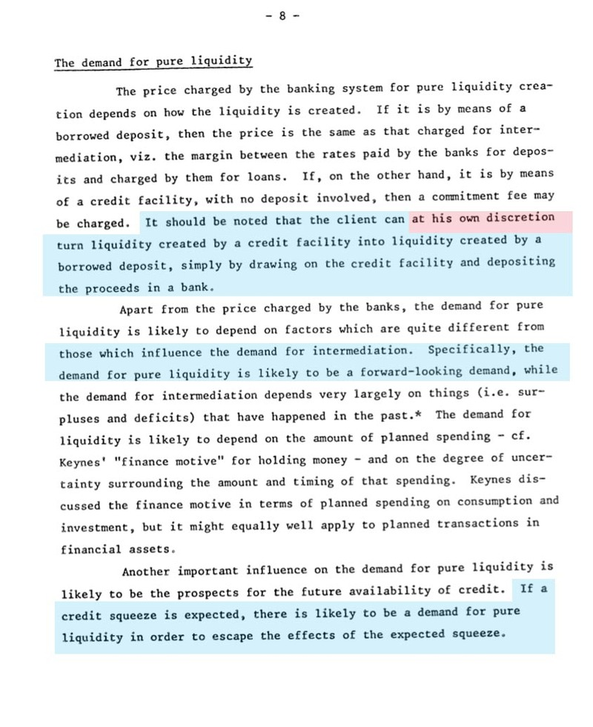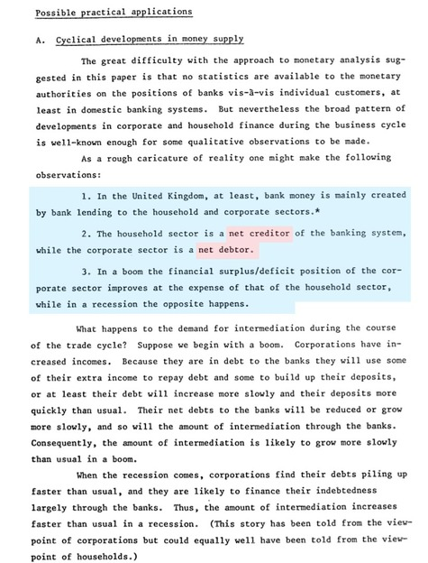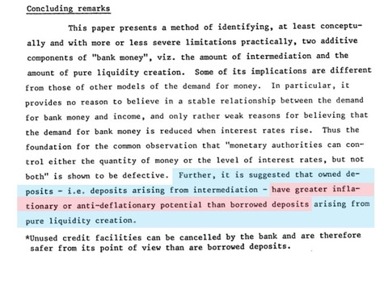
Note the business about the household sector [that is you and me and everyone who isn't a banker or a pirate] is supposed to be a net CREDITOR while the corporations and banks are net DEBTORS. During the previous 5 years the bankers loved to tell us that there was a savings glut in Asia so we had an obligation to suck that up by running up our household debts. We did this and now we are in a situation of too much debt, not too much savings. And any savings in Asia are being sopped up by inflation of food, fuel and housing over there. The last line of this old report are ominous: 'intermediation' deposits from the central banks are VERY inflationary due to the fact that it is pure red ink fake Funny Money™ based on nothing at all except deep government debts.
Now the only question is, when will Kohn retire? He should leave, too. Follow Mishkin into the Ivory Tower fortress where he can teach people how to be stupid.

Excerpt from
Central Bank Impotence and Market Liquidity
By
Henry C.K. Liu http://henryckliu.com/page137.html

………………………
Central Bank Impotence
But the time has long passed when central banks adding liquidity to the financial system can help a liquidity crisis in the market. When the Fed injects funds directly into the money market through the repo window, banks and thrifts and other non-bank financial institutions that need funds can participate. With the daily volume of transaction in the hundreds of trillions of dollar in notional value of over-the-counter derivatives, the Fed would have to inject fund at a much more massive scale to affect the market. Such massive injection will mean immediate and sharp inflation. Worse yet, it will cause a collapse of the dollar.
When the Fed adds liquidity directly into the banking system through the discount window, it injects high-power money into banks by making interest rate for overnight interbank banks loans within its set target. The theory is that banks will in turn be able to make loans at interest rates deemed appropriate by the Fed, thus relaying the added liquidity to the market in multiple amounts because of the mathematics of partial reserve.
But just because banks are able to make loans at low interest rate does not mean banks can find borrowers with credit ratings to justify the low rates. John Maynard Keynes' concept of a liquidity trap is that market preference for cash positions can outweigh interest rate considerations. In a financial crisis, there may simple [simply] not be enough credit-worthy borrowers at any interest rate level and the [resulting] number of sellers [(would-be borrowers) may] stay stubbornly larger than the number of buyers [(erstwhile lenders)] because sellers need to sell precisely because they do not have credit worthiness to borrow even at low interest rates and buyers stay on the sideline waiting for even lower prices.
Even when the Fed lowers the discount rate, banks will only see their threat of insolvency reduced. Banks will still be sitting on piles of idle cash that they cannot lend. This is known as banks pushing on a credit string. Keynes insightfully observed that the market can stay irrational longer than most participants can stay liquid. Since central banks are now mere market participants because of the enormous size of the debt market due to the wide-spread use of structured finance with derivatives whose notional value adds up to hundreds of trillion of dollars, the market can stay irrational longer than even central banks can stay liquid, if central banks do not want to drive their currencies to the ground. With deregulated global financial markets, central bank capacity for adding liquidity to the banking system is constrained by its need to protect the exchange value of its currency. For the US, which depends on foreign central banks to fund its twin deficits, any drastic fall of the dollar will itself create a liquidity crisis from foreign central banks shifting out of dollar in their foreign exchange reserves.
Federal Reserve flow of funds data shows outstanding home mortgages in Q1 2007 to be at $10.4 trillion. About $1 trillion in mortgages are due for a reset by the end of 2007 alone. A 4% reset of interest rates on $1 trillion of mortgages would require addition payments of $40 billion. Agency-and GSE-backed mortgage asset amounts to $3.9 trillion. Issuers of asset-backed securities home mortgages asset amounts to $1.9 trillion. The numbers are further magnified hundred of folds by structured finance with high leverage which magnifies the cash flow caused by even the slightest interest rate volatility. Liquidity problem associated with counterparty default could quickly run up to trillions of dollars. What does the Fed hope to accomplish with injecting a mere $50 or 100 billion in the banking system, except to show its impotence? The Fed can keep the banks from failing, but it cannot prevent the harsh reckoning of the debt bubble economy.

…………………………………

